

Lab 9: Soil Moisture Sensing and Ubidots IoT Platform

Instructor: Rameez Ashraf

  - SMRTTECH 3CC3
  - Cloud Computing and Internet of Things
  - B. Tech - SMRTTECH

Submitted by: Nicolas Jao - 400450151
Partner (s): Jacob Kwan - 400453713
Lab Section: L04
Date of lab: November 4, 2025

Abstract
In this experiment, a soil-moisture sensor was interfaced with a microcontroller (Arduino) and connected to a PC running LabVIEW (using the LINX firmware) and linked to the cloud via Ubidots. In the first phase, real-time analog moisture-level data was acquired from the sensor and sent from the Arduino through LabVIEW to the Ubidots platform, where a custom dashboard displayed a waveform plot of moisture changes (for example, as the sensor was dipped into a cup of water). In parallel, a status LED indicator was driven locally on the Arduino when the moisture reading fell below a user-defined threshold. In the second phase, the cloud interface took on a control role: the user could adjust the moisture-threshold parameter via the Ubidots dashboard, and when the sensor’s moisture reading dropped below this threshold, an email alert was automatically issued to the user in addition to the LED indicator being activated. This bidirectional data-acquisition and control loop demonstrates how embedded sensing systems can be extended to cloud-based monitoring and actuation, enabling real-time visualization, remote parameter tuning, and proactive notification based on measured environmental conditions.

Results & Discussions
- Block diagram:
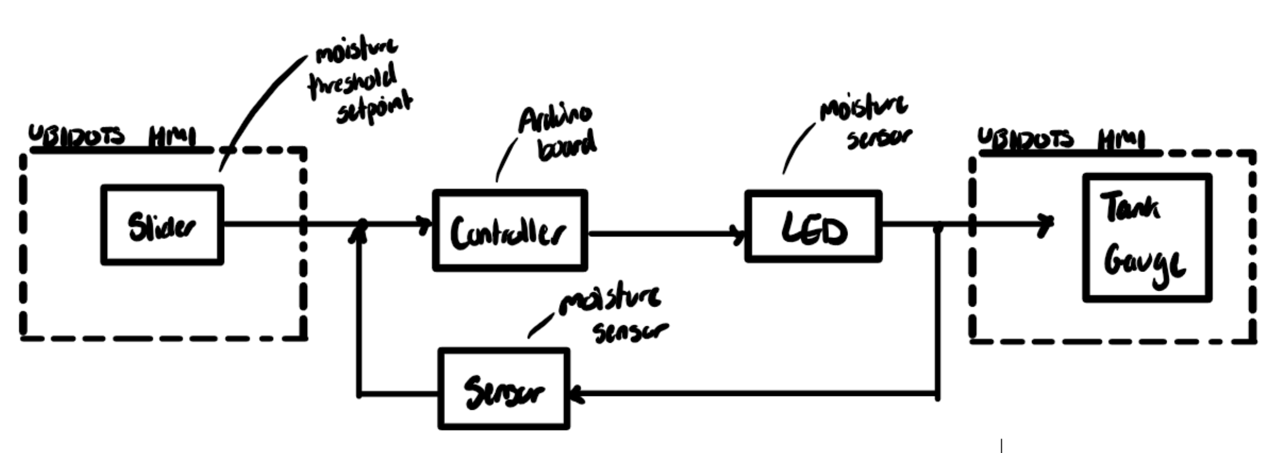
- The resistive moisture sensor measures electrical conductivity between probes by analyzing the amount of resistance between them. They are easy and cheap but prone to corrosion, drift, and interference from soil salinity. The capacitive sensor measures capacitance change, which is affected by water because of its high dielectric constant, which alters the sensor’s ability to store an electrical charge. They are more robust, stable, longer lasting and more accurate for many applications. They are better for long-term applications.
- The Formula Node block in Exercise 4 has two functions:
- Initialize and calculate the percent moisture based on the voltage of the sensor in a fully dry/fully wet environment. If the percent moisture is anything below 0 or above 100, it will simply be set to their respective outer limit.
- Set the LED as ON or OFF based on if the percent moisture calculated is above the given moisture threshold or not.
The necessary inputs for this formula node (specifically V_dry and V_wet) are specifically gathered from Exercise 4, Step 4. In this step, you determine the voltage readings for the fully dry and fully wet environments of the sensor. This range is needed to calculate the percent moisture in this block.
- An example of an application for soil moisture sensors is for landscape irrigation for making smart cities. Sensors can be installed beneath the soil around trees, planting beds, or green roofs in public parks. They can optimize when and how much to irrigate. They can enable cities to avoid over-watering green spaces, which saves both water and energy. They integrate well as an IoT device with smart-city platforms because maintenance crews get notified when certain zones need attention rather than relying on fixed schedules. Their real-time data can also aid research and find metrics on how much water is saved with this method.
- Improvement suggestion: a “Troubleshooting” page with steps to try on common errors students run into during the lab. This goes for all lab manuals. For example, students run into errors getting “RX Topic” to show up. The Troubleshooting page can have a section that explains they can try unplugging and replugging the Arduino to the PC or deleting the variables on Ubidots and recreating them. This troubleshooting page can be built over time from students’ experience doing these labs so mistakes are not repeated. Also another suggestion: remove the abstract and conclusion requirements in the lab reports? They feel useless to me. Why not just make the lab reports just answering the submission questions?

Conclusion
This experiment demonstrated the successful integration of a soil-moisture sensor, an Arduino-based embedded system, the LabVIEW (via LINX firmware) running on a PC, and the Ubidots cloud platform to create a complete Internet of Things (IoT) soil-moisture monitoring and alert system. Real-time moisture levels were captured by the sensor, transmitted via the Arduino to LabVIEW and then forwarded to Ubidots, where a waveform panel visualised the moisture fluctuations as the sensor was dipped into water. A user-configurable moisture threshold was implemented, with a local light indicator triggered when readings fell below the threshold, and cloud-based alerting (an email) issued when the low-moisture condition was detected remotely. The experiment thus demonstrated effective one-way data acquisition and threshold-based local actuation, as well as remote parameter control and alerting via the cloud. Overall, the system validates how a physical sensing device can be extended into a cloud-connected monitoring and notification platform, suitable for applications such as smart gardening, automated irrigation and remote environmental monitoring.

